131 Week 4 Lab:
Protists, Fungi, Porifera & Radiata

https://wendystjohn.summerlark.net/2021/02/10/131-w4/

Protists
Choose any 7 of the organisms shown in the video, provide an identification, and answer the associated questions. Pause and rewind as much as needed to answer the first group of questions.

1)
What is this organism’s number (from the black screen on the video)?

Identification – What type of organism is it?

Is it single-celled, or multicellular?

Describe how it moves. Does it have structures for movement?

Do you think this organism performs photosynthesis? Why or why not?

2)
What is this organism’s number (from the black screen on the video)?

Identification – What type of organism is it?

Is it single-celled, or multicellular?

Describe how it moves. Does it have structures for movement?

Do you think this organism performs photosynthesis? Why or why not?

3)
What is this organism’s number (from the black screen on the video)?

Identification – What type of organism is it?

Is it single-celled, or multicellular?

Describe how it moves. Does it have structures for movement?

Do you think this organism performs photosynthesis? Why or why not?

4)
What is this organism’s number (from the black screen on the video)?

Identification – What type of organism is it?

Is it single-celled, or multicellular?

Describe how it moves. Does it have structures for movement?

Do you think this organism performs photosynthesis? Why or why not?

5)
What is this organism’s number (from the black screen on the video)?

Identification – What type of organism is it?

Is it single-celled, or multicellular?

Describe how it moves. Does it have structures for movement?

Do you think this organism performs photosynthesis? Why or why not?

6)
What is this organism’s number (from the black screen on the video)?

Identification – What type of organism is it?

Is it single-celled, or multicellular?

Describe how it moves. Does it have structures for movement?

Do you think this organism performs photosynthesis? Why or why not?

7)
What is this organism’s number (from the black screen on the video)?

Identification – What type of organism is it?

Is it single-celled, or multicellular?

Describe how it moves. Does it have structures for movement?

Do you think this organism performs photosynthesis? Why or why not?

8)
What is this organism’s number (from the black screen on the video)?

Identification – What type of organism is it?

Is it single-celled, or multicellular?

Describe how it moves. Does it have structures for movement?

Do you think this organism performs photosynthesis? Why or why not?

9)
What is this organism’s number (from the black screen on the video)?

Identification – What type of organism is it?

Is it single-celled, or multicellular?

Describe how it moves. Does it have structures for movement?

Do you think this organism performs photosynthesis? Why or why not?

10)
What is this organism’s number (from the black screen on the video)?

Identification – What type of organism is it?

Is it single-celled, or multicellular?

Describe how it moves. Does it have structures for movement?

Do you think this organism performs photosynthesis? Why or why not?

Questions:

- Do you think all of the species we viewed under the microscope today are very closely related to one another? Explain your answer.

- What did all the organisms viewed today have in common, in terms of their habitat?

Fungi
Label the diagram below (feel free to color it as well).

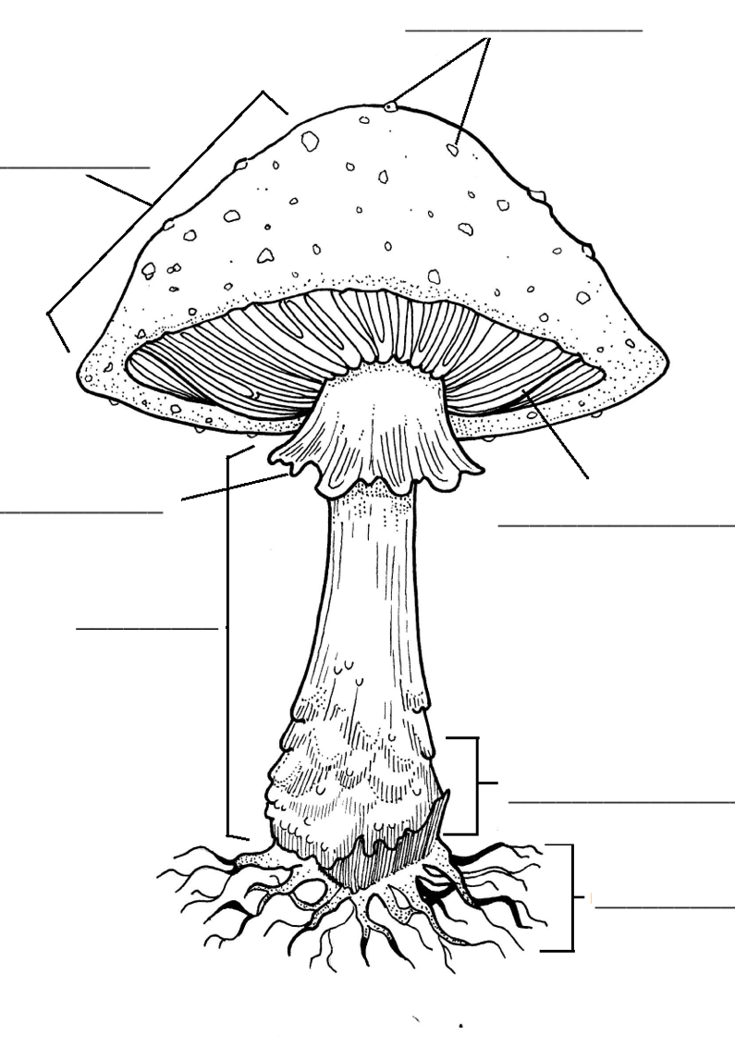
Mushroom Excursion

Specimen # | Type of Fungus
1
2
3
4
5
6
7
8
9
10

Porifera
https://wendystjohn.summerlark.net/2021/02/11/131-w4-porifera/

Sponge diagram:
- Label the structures
- Color choanocytes in purple
- Color incurrent pores (ostia) in green
- Draw a blue arrow that shows the flow of water through the sponge

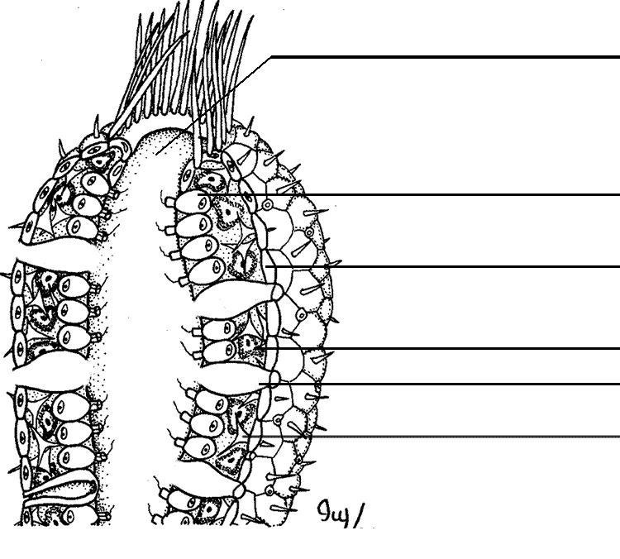
- What type of cell is used to capture food in sponges?

- Which protozoan do they resemble?

- What other types of cells might you find on these specimens?

Cnidaria

Class Scyphozoa

- What is a tissue?

- What are the two body forms of Cnidarians?

- What is the common name of Aurelia aurita?

- What is the meaning of tetramerous (if you missed it during the video, look up the word in the Root Words list we worked with last week).

- What body form does the “typical” jellyfish exhibit?

- Where does digestion take place?

- What structures allow the jellyfish to sting prey?

Class Anthozoa

- What is the body form of the specimen we are examining?

- What are the three main regions? present

- How does this animal adhere to a substrate?

- Describe the tentacles. What is their primary purpose?

- Where does fertilization take place?

Homework Assignment: Sketches
For homework, you will complete two sketches based on the lab you have just completed, following the guidelines provided by your lab instructor during the biological illustration activity. Make sure to give your sketches a title, and sign and date them.
1) Choose one of the organisms in the Protist video and sketch it, labeling at least two structures.

2) Return to the video of the moon jelly and sketch the specimen. Label the following structures:
  - Bell
  - Margin
  - Tentacles
  - Oral arms
  - Mouth
  - Gastric pouches
  - Gonads

