131 Week 6 Lab: Ecdysozoa

Nematoda
Nematodes are a diverse animal phylum inhabiting a broad range of environments. Unlike flatworms, they have tubular digestive systems with openings at both ends. Nematode species can be difficult to distinguish from one another, so estimates of the number of nematode species may change rapidly over time. A 2013 survey of animal biodiversity puts this figure at over 25,000. The use of DNA barcoding and the increasing acknowledgment of widespread cryptic species among nematodes, have placed the figure closer to 1 million species.

- Look at the nematode species on display. What differences can you see between them? Make a quick sketch of one live specimen below, and label the head and any other structures you can identify.

Tardigrades
Tardigrades have been found everywhere in Earth's biosphere, from mountaintops to the deep sea and mud volcanoes, and from tropical rainforests to the Antarctic. Tardigrades are among the most resilient animals known, with individual species able to survive extreme conditions — such as exposure to extreme temperatures, extreme pressures (both high and low), air deprivation, radiation, dehydration, and starvation — that would quickly kill most other known forms of life. They have even survived exposure to outer space.

- Why do you think their common name was given to them?

Crustacea
Several crustaceans are display in the lab classroom. Some are herbivores, some are carnivores and scavengers, and some are suspension feeders. Observe their behavior, especially feeding behavior if you have the opportunity to watch them feeding.
- Compare the feeding and walking appendages found on each specimen. What are the major differences between them?

- Record the name of each species on display and describe the differences among them either in words or with quick sketches.

Crayfish External Anatomy
In the space below, draw a dorsal view of the crayfish specimen you have been provided.
Label the ventral view of the crayfish below, then answer the follow-up questions:
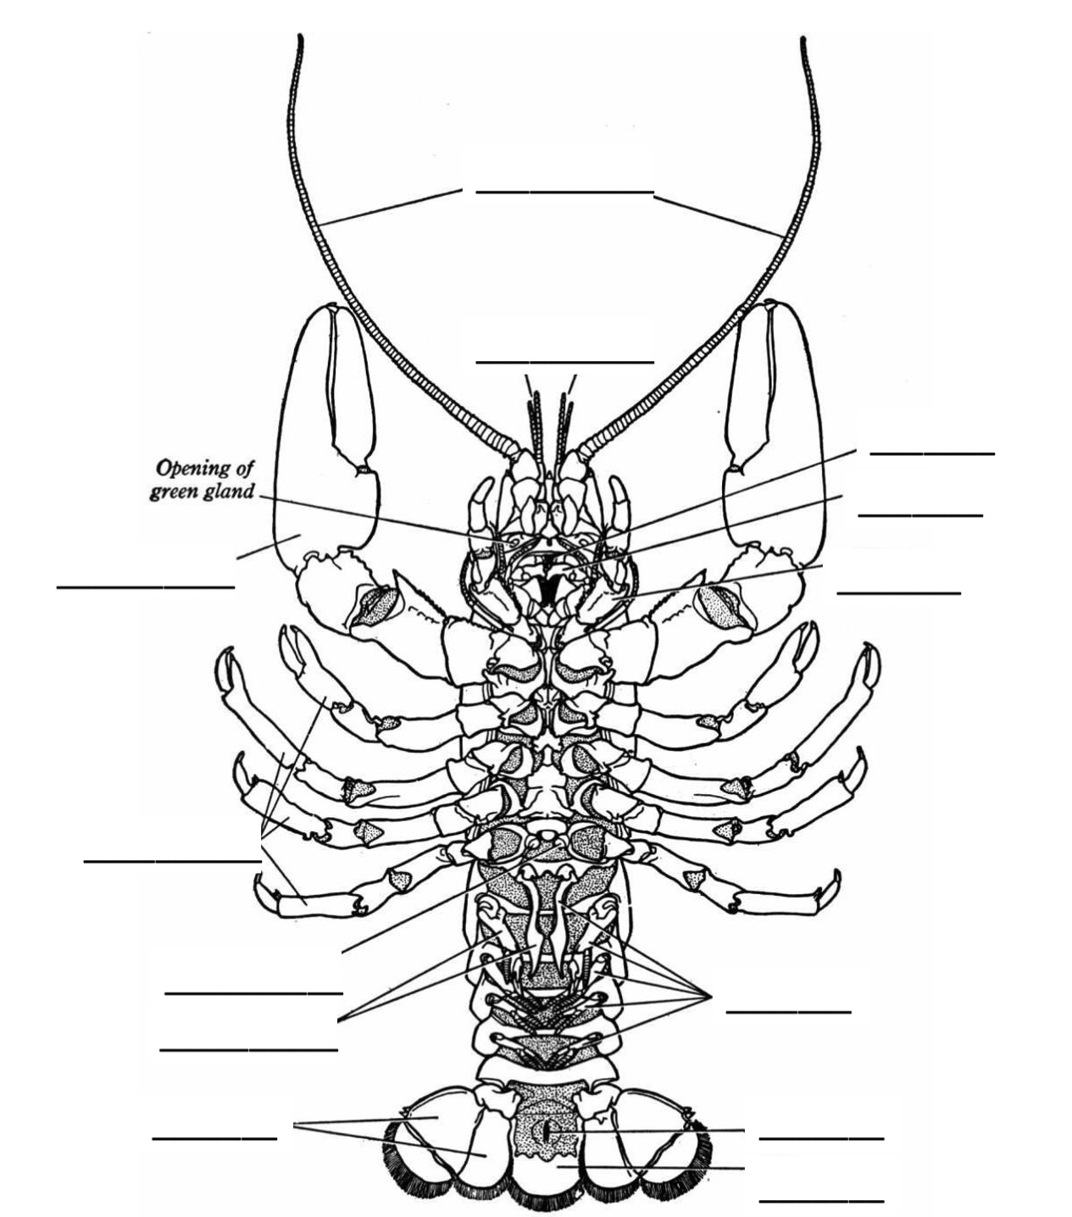

- How many segments and appendages are there in the cephalothorax?

- How many abdominal segments are there?

- How many abdominal appendages are there?

- In most male malacostracans, the anterior two pleopods are modified into copulatory organs. They are enlarged and point in a forward direction between the last walking legs (which are attached to the cephalothorax). What are the differences between these two segments and the posterior pleopods.

Chelicerata
Examination of Merostomata (a marine chelicerate)
Examine the dried horseshoe crab specimens closely as well. Note the compound eyes, the carapace, the pedipalps and number of legs on the ventral side, and the presence of the book gills, which are legs that have been modified into respiratory structures.
- Based on its physical features, to what group of invertebrates do you suspect the horseshoe crab is the most closely related?

- Now, if I were to tell you that they lack antennae, and that they have specialized sensory structures called pedipalps, which group do you think might be their closest relatives?

Examination of arachnids (terrestrial chelicerates)
Some features of terrestrial arachnids clearly represent homologies with those of their marine chelicerate relatives. For example, they have book lungs, which are modifications of the book gills that horseshoe crabs use to respire.
- What is the difference between a gill and a lung?

The appendages are also clearly homologous, although they vary in size and shape. The same thing is true for the overall body form. All arachnids have two main body segments, a cephalothorax and abdomen, but the size and shape of these parts varies.
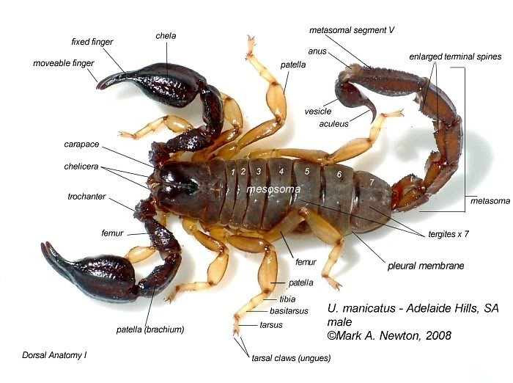
Examine the specimens of spiders and scorpions. Note the similarity of their chelicerae.
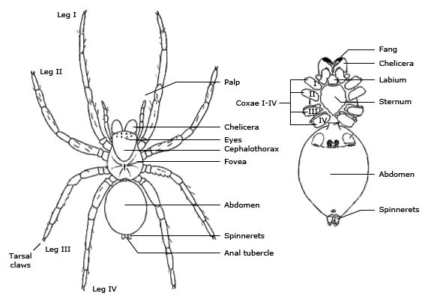
- Which arachnids have larger pedipalps, spiders or scorpions?

- What are the differences you can see in the cephalothorax and abdomen between spiders and scorpions?
Your lab instructor will show you a video featuring a friendly spider. There is also a live specimen on display in the classroom.

- What type of spider is shown in the video?

- What type of spider is on display in the classroom?

- Describe some of the differences and similarities between the two.

- Do spiders bite? Or don't they??

Myriapoda
Subphylum Myriopoda. Body divided into a head and a long trunk with many nearly identical segments with legs on them. Relative lack of tagmatization (little fusion of segments). In contrast to the crustaceans, these organisms all have uniramous (one branch vs the 2-branched biramous appendages of which arthropod taxon?) appendages. They are terrestrial.

Class Chilopoda. The centipedes. Flattened body with one pair of walking legs per segment. Appendages on first trunk segment modified from legs into poisonous fangs.

Class Diplopoda. The millipedes. Two pair of walking legs per diplosegment (pairs of segments that appear to have fused), body often cylindrical.

- View the specimen(s) on display. Describe the similarities and differences between them.

Hexapoda
- What adaptation in particular lead to the great success of insects?

- Which group of insects is most diverse?

Direct Development

Order Orthoptera—crickets, crickets, walking sticks and praying mantids have four wings folded over their backs (“ortho”= straight, “ptera” = wing). The immature 'nymphs' resemble the adults, except that they do not have any wings. Most species eat plants or detritus, with the spectacular exception of the predatory praying mantis. Many species of orthopterans are shaped or colored for concealment. Observe the specimens from the different groups and compare their body forms.

- Which of the orthopterans on display best represents some form of crypsis?

Partial metamorphosis

Order Odonata-­‐ Dragonflies and damselflies. These insects have a long-lived aquatic stage called the naiad, which lives for several years in streams and ponds. The naiad feeds on aquatic insects and even on tadpoles. The adults are terrestrial flyers and fierce predators that usually feed on other arthropods. They have four similarly shaped wings. Odonta means “toothed.”

- Compare and contrast a dragonfly to a damselfly. List features that are the same and features that are different in the space below. Pay attention to the arrangement of its wings, body form, and eye morphology.

Complete Metamorphosis

Order Lepidoptera—The butterflies and moths. These insects have scaly wings (name means “scale-­‐wing”). The adults often have sucking mouthparts, modified into a sort of siphon to consume nectar from flowers.

- Examination of butterfly wings-­‐ Look at a butterfly's wing under the dissecting microscope. Describe what you see, including the pattern, colors, and the structures that make up the pattern.

Look at the “Butterflies of California.”

- List three species that appear to exhibit aposematic coloration
a)

b)

c)

- What are bright colors often a warning against?

8. List two species that seem to exhibit cryptic coloration
a)

b)

Look at "Insects in the Garden" and "Characteristics of Garden Insects"

- List three prey species (ones that could be garden pests)
a)

b)

c)

- List three predators (beneficial “bugs” that could help reduce pests in the garden without the use of insecticides)
a)

b)

c)
