Animal Body Plans and Dichotomous Keys

The Language of Science

Deciphering Biology Terms

With a partner, use this list to figure out the meaning of each of the terms below, following your instructor’s example.

1. Pterodactyl - Root words:
Your definition:

2. Homeothermic - Root words:
Your definition:

3. Autotroph - Root words:
Your definition:

4. Parthenogenesis - Root words
Your definition:

5. Sympatry - Root words:
Your definition:

6. Heterozygous - Root words:
Your definition:

Who Am I?

Below are the scientific binomials (bi =” two;” nomen = “name”) of three organisms with which you are probably familiar. Piece together the meaning of the root words, and then see if you can guess the identity of the animal in question.

7. Haliaeetus leucocephalus - Root words:
I am:

8. Phascolarctos cinereus - Root words:
I am:

9. Ornithorhynchus anatinus (Hint: I’m a mammal, not a bird) - Root words:
I am:

Name that Critter

Using the list of root words, come up with a “scientific” binomial for each of the organisms pictured below.

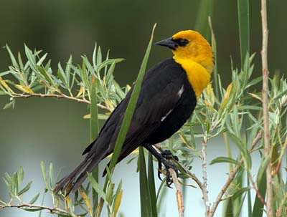
Your “scientific” name:

Meanings of the root words you chose:

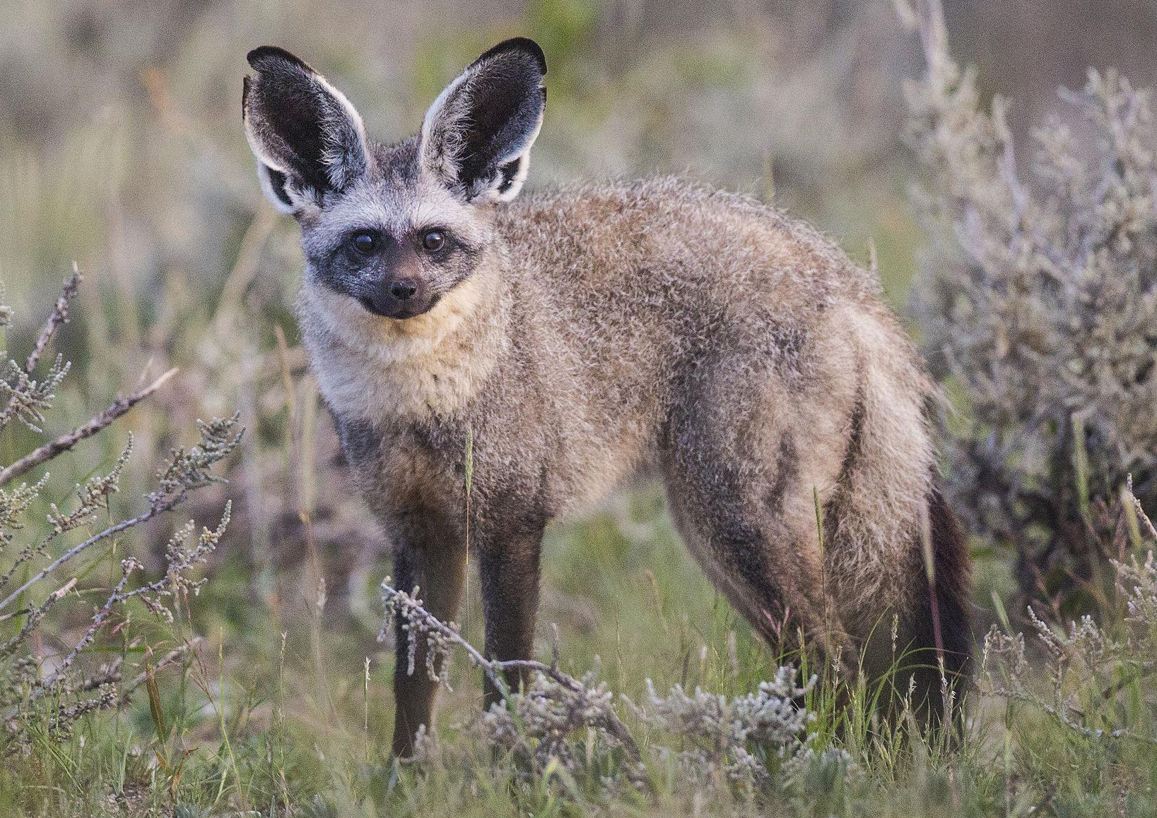
Your “scientific” name:

Meanings of the root words you chose:

Brainstorming about Body Plans

What do you think the term “body plan” means?

What morphological characters would you consider important in defining a unique body plan when analyzing an organism? What features are less, or unimportant?

How would you differentiate among animals with different body plans?

Why do you think groups of animals share similar body plans?

Using the information in your textbook (primarily Chapter 32), describe the terms below, and explain how they apply to animal body plans.

Body cavities: what are they, what function do they serve, what are the types of body cavities discussed in lecture and in the text, and which groups of animals have which kind of cavity? (Page 681)

Digestive system: What types of GI tracts are there, and which animal taxa possess them? (Page 681)

Symmetry: what types of body symmetry are there and which animals display these? (Page 680)

Tissues: are they present, if they are, how many germ layers are there in different taxa—i.e., diploblasts vs triploblasts). (Page 679)

Protostome vs deuterostome (Page 682)

Segmentation, and role of HOX genes in body form patterning (Page 545)

Specimen # 1 |  | Phylum:
Step | Reason | Step | Reason
Specimen # 2 |  | Phylum:
Step | Reason | Step | Reason

Specimen # 3 |  | Phylum:
Step | Reason | Step | Reason
Specimen # 4 |  | Phylum:
Step | Reason | Step | Reason

Specimen # 5 |  | Phylum:
Step | Reason | Step | Reason
Specimen # 6 |  | Phylum:
Step | Reason | Step | Reason

Specimen # 7 |  | Phylum:
Step | Reason | Step | Reason
Specimen # 8 |  | Phylum:
Step | Reason | Step | Reason

Specimen # 9 |  | Phylum:
Step | Reason | Step | Reason
Specimen # 10 |  | Phylum:
Step | Reason | Step | Reason

Specimen # 11 |  | Phylum:
Step | Reason | Step | Reason
Specimen # 12 |  | Phylum:
Step | Reason | Step | Reason

Specimen # 13 |  | Phylum:
Step | Reason | Step | Reason
Specimen # 14 |  | Phylum:
Step | Reason | Step | Reason

Specimen # 15 |  | Phylum:
Step | Reason | Step | Reason

