131 Week 4 Lab:
Protists, Fungi, Porifera & Cnidaria

Protists
Examine the photograph of Euglena. See if you can identify a flagellum. Draw the specimen, including the nucleus, eyespot, flagellum, and paramylon (starch-like) granules. (You may refer to Figure 28.10 in the Campbell textbook, but do not draw from the figure in your book).

Examine the photograph of Ameoba. Amoebae move by extending pseudopods (false foot) in the direction they wish to move, anchoring the end, and letting the cytoplasm flow into it. This process also helps to engulf food. The cytoplasm forms a food vacuole around an ingested particle for digestion. Draw an Amoeba and label nucleus, pseudopods, and food vacuoles. (You may refer to the diagram included below, but do not draw from the diagram).

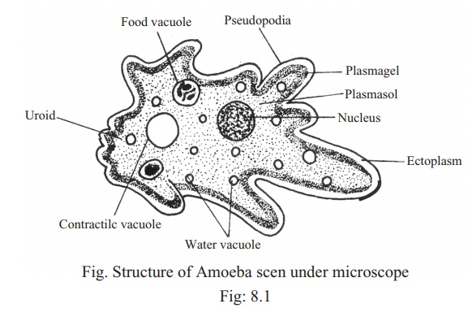

View the video of protists. Choose any 4 of the organisms featured in the video to provide an identification and answer the associated questions. You may not be able to identify all the organisms you find; in this case, just provide the best description that you can.

1)
Identification – What type of organism is it?

Is it single-celled, or multicellular?

Describe how it moves. Does it have structures for movement?

Do you think this organism performs photosynthesis? Why or why not?

2)
Identification – What type of organism is it?

Is it single-celled, or multicellular?

Describe how it moves. Does it have structures for movement?

Do you think this organism performs photosynthesis? Why or why not?

3)
Identification – What type of organism is it?

Is it single-celled, or multicellular?

Describe how it moves. Does it have structures for movement?

Do you think this organism performs photosynthesis? Why or why not?

4)
Identification – What type of organism is it?

Is it single-celled, or multicellular?

Describe how it moves. Does it have structures for movement?

Do you think this organism performs photosynthesis? Why or why not?

Questions:

- Do you think all of the species we viewed under today are very closely related to one another? Explain your answer.

- What did all the organisms viewed today have in common, in terms of their habitat?

- Choose one of the organisms you found on the video and sketch it, labeling at least two structures.

Microscopy Identification Guides

You may wish to reference internet sources as a supplement to these guides.

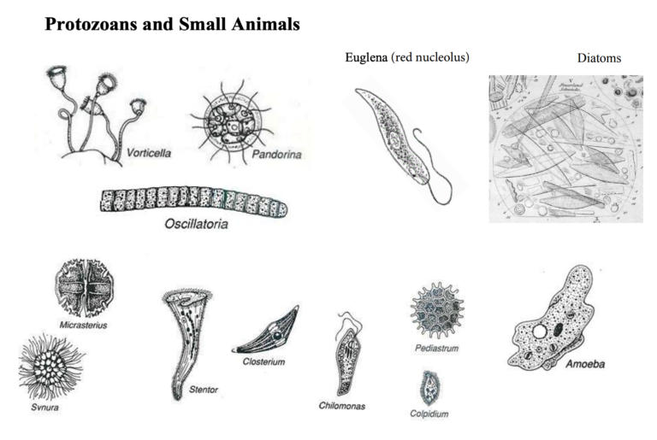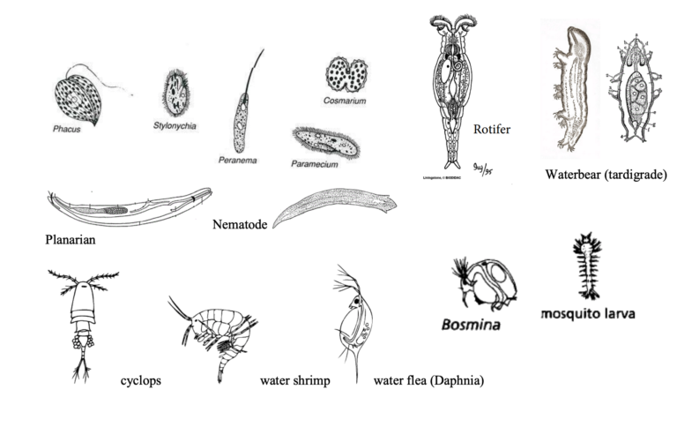
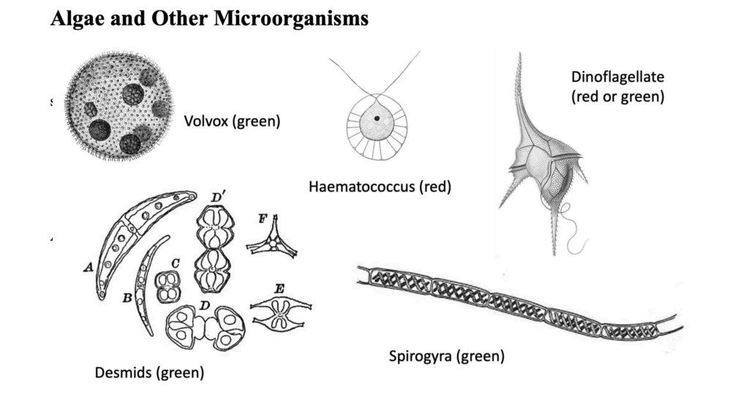

Good internet resources:

- https://microscope-microscope.org/pond-water-critters-protozoan-guide/
- http://www.microscopy-uk.org.uk/index.html?http://www.microscopy-uk.org.uk/pond/index.html

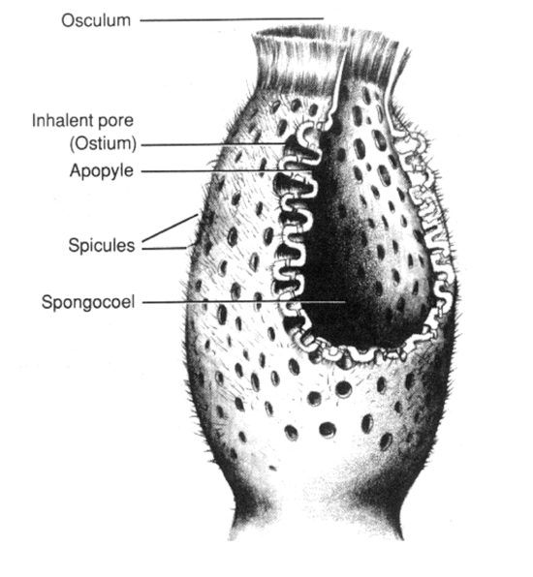
Porifera
  - Sponges exhibit one of three body types. Watch the video linked on the website again, and this time look for the pores called ostia through which water enters the sponge, and the larger oscula through which water exits.
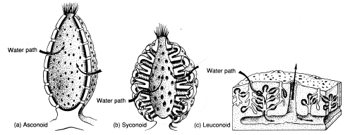

- What type of cell is used to capture food in sponges? (Refer to Chapter 33 in your textbook).

- Which protozoan do these cells resemble?

3. Sponge diagram:
  - Label the structures
  - Color choanocytes in purple
  - Color incurrent pores (ostia) in green
  - Draw a blue arrow that shows the flow of water through the sponge

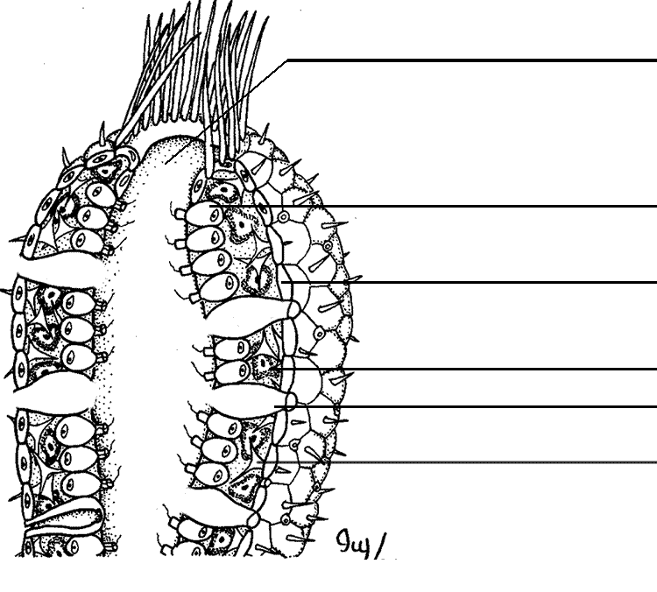

Cnidaria

Class Hydroza

Examine the photos of Obelia. A marine hydroid, Obelia has a sessile polyp and free-­‐living medusa stage. The polyps grow on a stalk, and one individual may consist of several such stalks (called a colony). There are two kinds of polyps in this species: feeding polyps that resemble Hydra individuals, and reproductive polyps. The medusae develop on and bud off of the reproductive polyps. This organism undergoes sexual reproduction during the medusa stage.

Below, draw the life cycle of Obelia using drawings of the different stages you see on your slides. You may refer to Chapter 33 in your textbook, but you should draw as many structures as possible from the phtographs; do not copy the drawing from the book!

Class Scyphozoa

Examine photographs of Aurelia aurita. In the Scyphozoan class, the medusa stage is the most conspicuous one (the opposite is usually true for the Hydrozoa). When an Aurelia egg hatches, a larva develops, which eventually settles onto a substrate as a small polyp, the scyphistoma. This structure releases medusae.

Below, draw a scyphistoma and note where the medusae bud off from it.

Class Anthozoa

Examine the microscope photograph of Metridium. In the class Anthozoa, there is no medusa stage. These organisms may be either solitary or colonial. If you take a cross section from these animals, you will see that their gastrovascular cavity is divided into several sections with structures called septa. Examine the living and preserved specimens of corals and sea anemones. Note that the polyps are missing from dry coral specimens. They would normally be found living on top of the stony coral structure they secrete. They can only be seen while the animals are alive or if they are preserved.

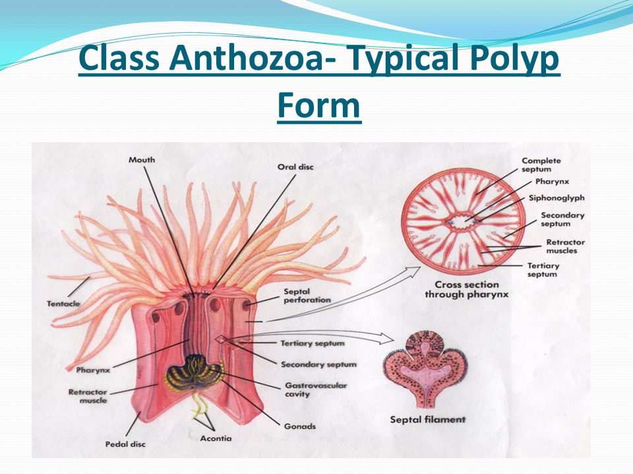

View the video of live anemones, and select one to sketch. Identify the tentacles, pedal disk and mouth on the drawing. Now draw what you see on either the cross- or longitudinal-section of a prepared Metridium slide. Identify the septa, pharynx and any other structures you may be able to see. Indicate on your drawing of the live anemone (with a line and a label) what view the prepared slide you have drawn represents.

Fungi
Using information from Chapter 31 in your textbook, and the Mushroom ID video in the pre-read website (https://www.youtube.com/watch?v=5CwqZXolgQc), label the diagram below (feel free to color it as well).

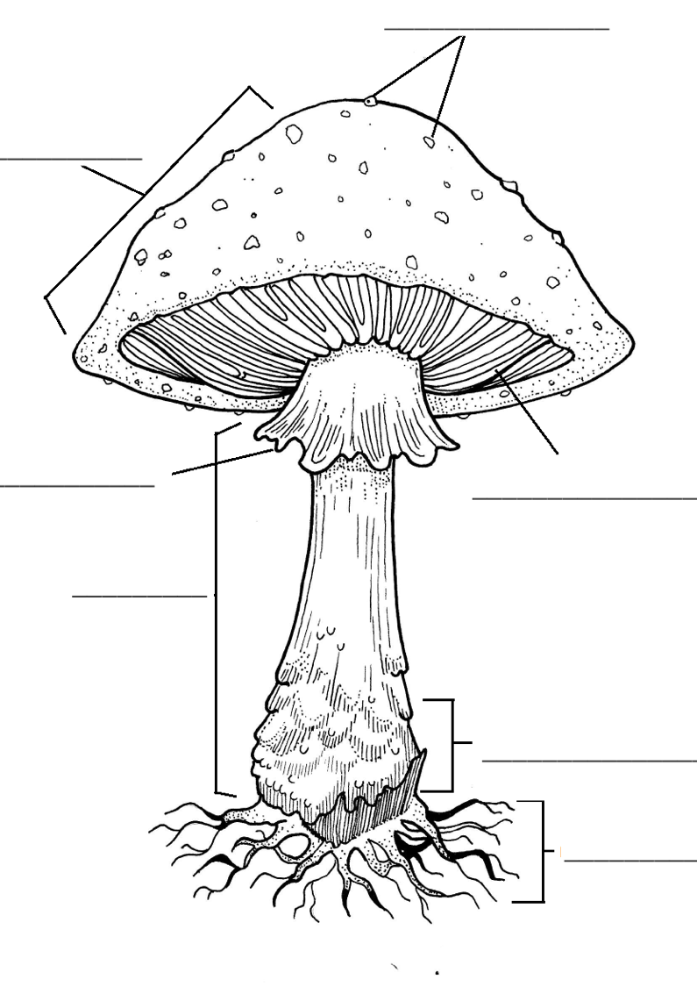

Mushroom Excursion

Use the dichotomous key below to identify the various mushroom specimens found on your virtual “mushroom excursion.”

Specimen # | Type of Fungus
1
2
3
4
5
6
7
8
9
10

