131 Week 7 Lab: Echinoderms

Echinoderm Diversity and Anatomy
Close examination of sea urchins

View the video that shows a sea urchin eating seaweed.

Describe what happens:

Pay special attention to the tube feet.

Describe what they are doing:

Do a sketch that shows several tube feet:

In the video, the sea urchin is positioned so that its oral side is facing upwards. Can you see the 5 teeth that connect to the internal jaws called Aristotle’s lantern? Compare what you see in the video to the image of Aristotle’s lantern. Draw both.

The ossicles that make up the sea urchin’s test are internal, but surround all the visceral organs. Arthropods molt their exoskeleton to grow. When sea urchins grow they need to increase the size of their test to accommodate their increasing viscera. Since they don’t molt, and their test surrounds their internal organs, how do you think they manage to make their test grow larger as they grow? Where do they add new material?

Close examination of sea stars

There are three videos for you to watch. First you will watch a video that shows the action of tube feet. There is also a video that examines the external anatomy, and another that walks through the steps of a dissection.

What structures are visible on the aboral surface of the specimen?

Draw an oral view of the animal. Identify the ambulacral groove and the tube feet

Now, label the following structures on the diagram below:

- Coelom—the space containing the internal organs/viscera
- Stomach—5-­‐lobed, sac-­‐like structure dorsal to the mouth in central disc region, connects to caeca
- Digestive glands—pair in each arm connect to stomach. Also known as hepatic caeca.
- Gonads—found under the caeca in each arm. Testes or ovaries (sexes separate in echinoderms)
- Water vascular system: includes
  - Stone canal: connects madreporite to ring canal
  - Ring canal: hard, circular tube-­‐like structure, around mouth
  - Tiedemann bodies: swellings (9) along ring canal
  - Radial canal: from ring canal down each arm, connects water vascular system to ampullae
  - Ampullae: spherical “bulbs” connect to tube feet

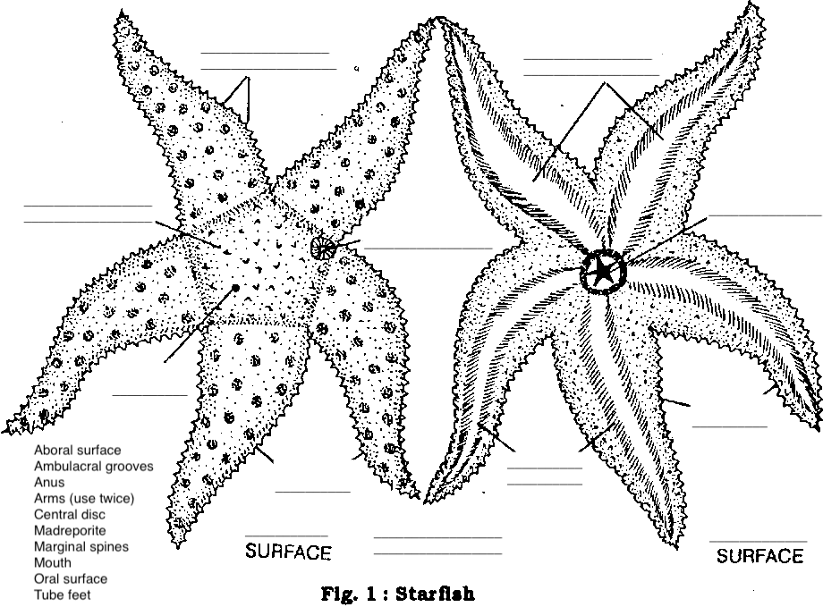

SHAPE OF LIFE: ECHINODERMS (FILM)
Listen for answers to the following questions as you watch the film.

What allows seastars to hold their position effortlessly for hours?

How fast can an urchin eat seaweed?

How do soft-­‐bodied sea cucumbers defend themselves from predators?

What do brittle stars eat?

Can seastars see?

If yes: Can they see light?

Can they form an image?

Describe how a seastar eats a bivalve.

