# Station 0 - Amniote Review

1. Identify the ancestral sister taxa of Amniotes.
2. Identify the **Amniotes** in the phylogeny below.
3. Identify the **Synapsids** and **Sauropsids** in the phylogeny below.
4. Identify the **Testudines** in the phylogeny below.

4a. Indicate the hypothesized origins of turtles discussed in class.

1. Identify the **Lepidosaurs** in the phylogeny below.
2. Identify the **Archosaurs** in the phylogeny below.

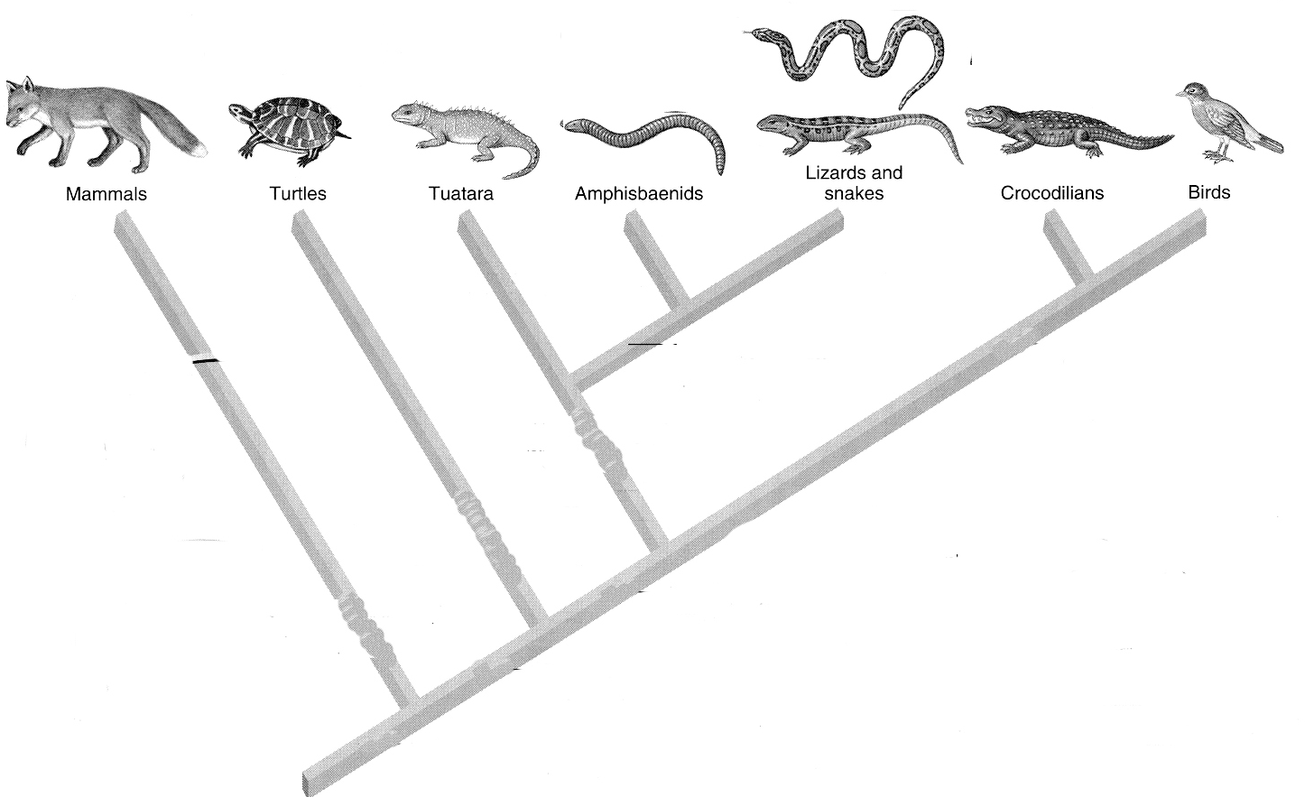

**Station 1 – Superorder Lepidosauria**

Name the orders of living organisms that fall within the Lepidosaur lineage.

Identify four key characteristics of Lepidosaurs.

What is relationship of the Amphisbaenians to other Lepidosaurs?

Rynchocephalia

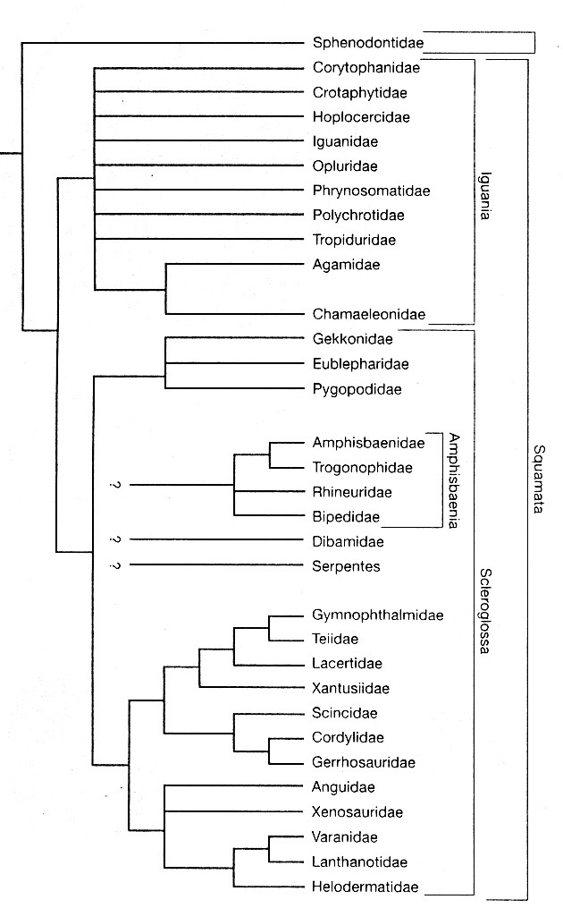

What is the relationship of the snake   
lineage (serpentes) to other   
Lepidosaurs?

 List below non-snake Families   
that you need to know (indicated   
in display)

# Station 1 - Order Squamata - Snakes and Lizards

Sometimes the squamates are considered to have three main common forms Snakes, lizards, and:

If you examined a squamate skull, would you see the classic diapsid condition or some modification (if so what?).

What is unique about the intromittant organ in squamates?

How does caudal autonomy work and do all squamates do it?

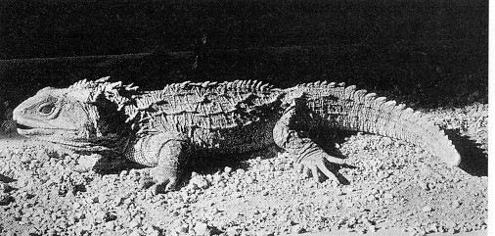**Station 2 - Order Rynchocephalia**

# Family Sphenodontidae - Tuatara

Why is this considered a true diapsid?

What is interesting/different about Tuatara teeth?

Why might it have these tooth conditions?

What is unique regarding the copulatory/intromittent organ in the Tuatara and how does it work around that condition?

What do you know regarding its conservation status?

# Subclass Lepidosauria

**Order Squamata**

Suborder Scleroglossa

# Family Gekkonidae – Station 3

* 1. Name a species (common name) found in California.
  2. What important climbing adaptation do geckos have?
  3. How will you be able to distinguish a gecko?

# Family Scincidae – Station 4

1. Name two species of skink found in California (know common names and genus).
2. How will you distinguish skinks from other lizards?

# Family Teiidae – Station 5

1. What is parthenogenesis?
2. What is a species of Teiid in California (common names and genus)?

# Family Anniellidae

1. Name two or three characteristics that distinguish this lizard from most other lizards?
2. What is a species of Anniellid found in California (common name and genus name)?

**Family Anguidae – Station 6**

1. What is the common name for this type of lizard?
2. Name two forms of Anguid found in California (common names and genus)?
3. How will you distinguish Anguids from other lizards?

# Family Helodermatidae-

1. What distinguishes this group from other squamates?
2. Where are these found?
3. What can you say about its feeding adaptations?

# 

# Suborder Iguania

Iguanid-like lizards (9 families)

# Family Iguanidae – Station 7

Write down the species (common names) found in California and a description of that species that would help you to identify it.

**Subclass Lepidosaura**

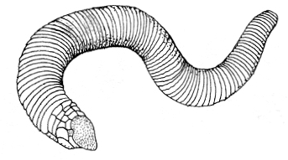**Order Squamata**

Suborder Scleroglossa

# Amphisbaenia – Station 8

What does it mean that they are fossorial?

What skull characteristics distinguish this group and why?

# Subclass Lepidosaura Order Squamata Suborder Serpentes

**Family Boidae –**

1. What feeding adaptation is characteristic of this family?
2. what type of fang condition do these have?

# Family Viperidae – Station 9

1. What style of fangs do these have?

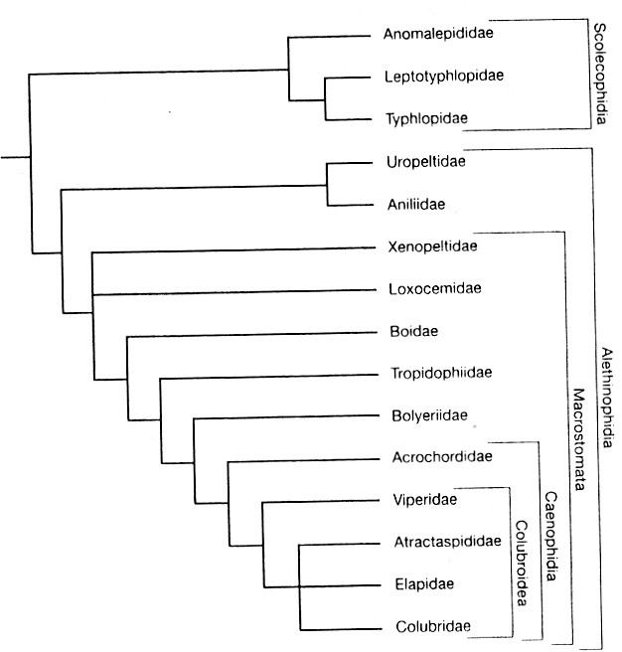

1. What are pit organs?

# Family Elapidae –

1. What style of fangs do these have?
2. What form of Elapid might you mind find in the U.S?
3. Name three old world forms?

# Family Hydrophiidae –

1. Where are these snakes found?
2. What obvious external morphological modification has been made for the lifestyle of these snakes?

# Family Colubridae – Station 10

1. What style of fangs are found among the Colubrids?
2. Provide examples of six species of Colubrid snakes found in California (common names).

# 

# Snake Structures – Station 11

Examine the snake skull and look for articulation points used in cranial kinesis

1. Describe how a snake can eat an item larger than its head.
2. Distinguish between streptostyly, mesokinesis, prokinesis, and metakinesis.
3. Distinguish between aglyphous, Opisthoglyphous, proteroglyphous, and solenoglphyphous
4. Examine snake skins – new and old – and describe the process of ecdysis in snakes.

General Snake questions

1. Which family accounts for 3/4 of the snakes in the western U.S.?
2. Name the **Family** of the new world pit vipers.
3. Which **family** contains the world’s largest snakes?
4. Identify the **family** of marine snakes and name two characteristics of these snakes.
5. Which snake families described in lab today fall under the following categories?

## Proteroglyphous

## Solenoglyphous.

## Opisthoglyphous

## Aglyphous

1. Give the family name and examples of both old world and new world constrictors.

# Lepidosaur Overview

*Each question below refers to the families observed in lab today.*

1. Which family of lizards are known for their superior climbing adaptations?
2. Name 2 groups of Lepidosaurs without legs that are not considered snakes?
3. Which family of Lizards are poisonous?
4. Which family of lizards are widely distributed, prefer moist environments, and are known for their sleek look?
5. Which Family are known primarily as the whiptails?
6. Which large family has many species in North America including the Chuckwalla, earless lizards, spiny lizards, fence lizards, and horned lizards?
7. Which family contains the short-legged alligator lizards?
8. What distinguishes tuataras from lizards and snakes?
9. Based on the Range maps, which lizards are found in Sonoma County?
10. At home: sketch any of the species that we examined today.